**CSE543 Information Assurance and Security**

**Assignment 1**

**Fall 2014**

Submitted by:

Talasila Madhu Meghana

(1207740881)

**Task 1:**

Link to the main page of my website: <http://www.public.asu.edu/~mtalasil/>

**Task 2:**

Webpages in my index page/ home page

CSE001 - <http://www.public.asu.edu/~mtalasil/CSE001/cse001.htm>

CSE002 - <http://www.public.asu.edu/~mtalasil/CSE002/cse002.htm>

CSE003 - <http://www.public.asu.edu/~mtalasil/CSE003/cse003.htm>

CSE004 - <http://www.public.asu.edu/~mtalasil/CSE004/cse004.htm>

CSE005 - <http://www.public.asu.edu/~mtalasil/CSE005/cse005.htm>

**Directory Structure:**

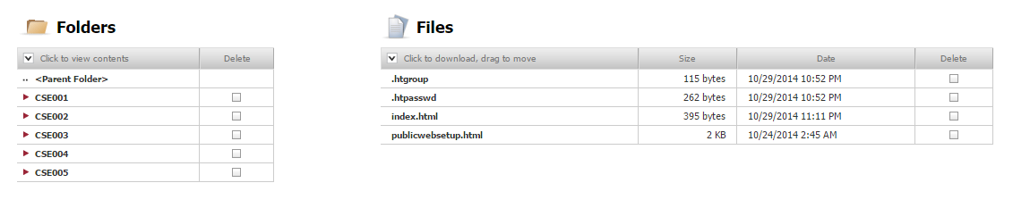

**Each folder Structure (Ex: CSE001)**

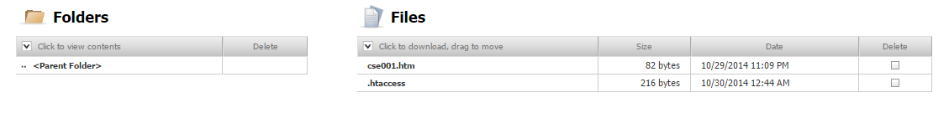

**The list of users with their passwords for accessing all the web pages specified in Task 2**

|  |  |
| --- | --- |
| **User Name** | **Password** |
| Alice | alice123 |
| Bob | bob123 |
| Chris | chris123 |
| Eve | eve123 |
| Dave | dave123 |
| John | john123 |

**Answers for Tasks 3 to 7**

**Task 3:**

1. Created one .htpasswd and one .htgroup files in www folder
2. Create one .htaccess file for each folder in www folder (CSE001, CSE002, CSE003, CSE004, CSE005).
3. This adds protection to the files. Also as I am not enclosing user names in .htaccess file, so one who acquire .htaccess file have nothing to do with that until they have .htgroup file.

**Task 4:**

Redundant Policies: (by the given definition of redundant policies)

1. Alice takes courses CSE001 and CSE002

4. Alice doesn’t take any course in Program B

Policy 1 is enough to know what all courses Alice is having. Policy 4 is redundant.

6. Dave takes course CSE005

7. Dave doesn’t take any course from Program A

Policy 6 is enough to know what all courses Dave is having. Policy 7 is redundant

|  |
| --- |
| **Task 5: Access control matrix for all the users** |

|  |  |  |  |  |  |
| --- | --- | --- | --- | --- | --- |
|  | **CSE001** | **CSE002** | **CSE003** | **CSE004** | **CSE005** |
| **John** | YES | YES | YES | YES | YES |
| **Alice** | YES | YES | NO | NO | NO |
| **Bob** | YES | YES | YES | NO | NO |
| **Chris** | NO | NO | YES | YES | YES |
| **Dave** | NO | NO | NO | NO | YES |
| **Eve** | YES | YES | NO | YES | YES |

**Task 6:**

The content of the .htpasswd file is of the format (userName: encryptedpassword). To encrypt the password I made use of MD5 hash function. As password in the .htpasswd file is in encrypted format it is hard to crack by looking at the file. However, there are more sophisticated techniques like “collision” to hack the password when .htpasswd file is in one’s possession. Following can be done to protect .htpasswd file:

1. Hide the .htpasswd file in a secure place from web or www directory where files are stored.
2. Change the name of the file in .htaccess

By this we can ensure our file is protected thereby users of our system.

**Task 7:**

Security Flaws with my website:

1. When a registered users login to one webpage in the website one gets access to all the webpages in which one is registered.
2. When one user logins to the system, the system is accessible to everyone who ever uses the machine until cookies are cleared.

We are making use of http:// to process our requests. Which does not encrypt the information while during request and response procedure. Making use of https:// will solve the issue as https:// is a secured version of http:// where connection is encrypted.

**The contents of “.htaccess” file (Different files for each webpage)**

**For CSE001**

AuthUserFile /afs/asu.edu/users/m/t/a/mtalasil/www/.htpasswd

AuthGroupFile /afs/asu.edu/users/m/t/a/mtalasil/www/.htgroup

AuthName "Please enter your ID and password"

AuthType Basic

require group CSE001 A Manager

**For CSE002**

AuthUserFile /afs/asu.edu/users/m/t/a/mtalasil/www/.htpasswd

AuthGroupFile /afs/asu.edu/users/m/t/a/mtalasil/www/.htgroup

AuthName "Please enter your ID and password"

AuthType Basic

require group CSE002 A Manager

**For CSE003**

AuthUserFile /afs/asu.edu/users/m/t/a/mtalasil/www/.htpasswd

AuthGroupFile /afs/asu.edu/users/m/t/a/mtalasil/www/.htgroup

AuthName "Please enter your ID and password"

AuthType Basic

require group CSE003 A B Manager

**For CSE004**

AuthUserFile /afs/asu.edu/users/m/t/a/mtalasil/www/.htpasswd

AuthGroupFile /afs/asu.edu/users/m/t/a/mtalasil/www/.htgroup

AuthName "Please enter your ID and password"

AuthType Basic

require group CSE004 B Manager

**For CSE005**

AuthUserFile /afs/asu.edu/users/m/t/a/mtalasil/www/.htpasswd

AuthGroupFile /afs/asu.edu/users/m/t/a/mtalasil/www/.htgroup

AuthName "Please enter your ID and password"

AuthType Basic

require group CSE005 B Manager

**The contents of “.htpasswd” file (One file for all the webpages) (username:encryptedpassword)**

Bob:$apr1$/NnhX2R7$v2jzl73BYWu4d9J11tdd6/

Chris:$apr1$uH5CYdKC$XOITX3ZTlWq/N6JoYxkKM.

Alice:$apr1$TSaD3r6D$0RoMbSanAjP1wX9JRsqxq.

Eve:$apr1$qq0ryK57$8dBtmHBnS5xWyKnBuw/M30

Dave:$apr1$uw2EnQ1B$kbMzppZ7HgsdhHGynxmxg/

John:$apr1$7.3UMCRs$aK7IO2LfnX6p/rnN7WVBg0

**The contents of “.htgroup” file (one file for all the webpages) (groupname: user1 user2)**

CSE001: Alice Eve

CSE002: Alice Eve

CSE003: Chris

CSE004: Eve

CSE005: Eve Dave

A: Bob

B: Chris

Manager: John